Project Based Learning

**Title of Project:** **Real-time GPS Tracking System Using C Language**

|  |  |  |
| --- | --- | --- |
| **Sr.No** | **Name of Students** | **PRN No** |
| **1** | **Vinit Patil** | **B24IT1040** |
| **2** | **Sarthak Patil** | **B24IT1044** |
| **3** | **Gaurav Jadhav** | **B24IT1054** |
| **4** | **Shreyash Mandlapure** | **B24IT1130** |
|  |  |  |

**Date: Faculty In-Charge**

# 1)Research :

**This project focuses on creating a cost-effective, real-time GPS tracking system using widely available components like the ESP8266 microcontroller and NEO 6M GPS module.**

**Secondary Research:**

* **Existing Systems: Popular GPS trackers such as Garmin offer advanced features but are costly and complex for general users.**
* **Market Gaps: Identified a need for affordable and easy-to-use solutions for personal safety, asset monitoring, and fleet management.**

**Primary Research:**

* **Conducted field tests using the NEO 6M GPS module under different conditions (urban vs. rural environments) to observe data accuracy.**
* **User interviews revealed interest in features like live tracking on Google Maps and geofencing notifications.**

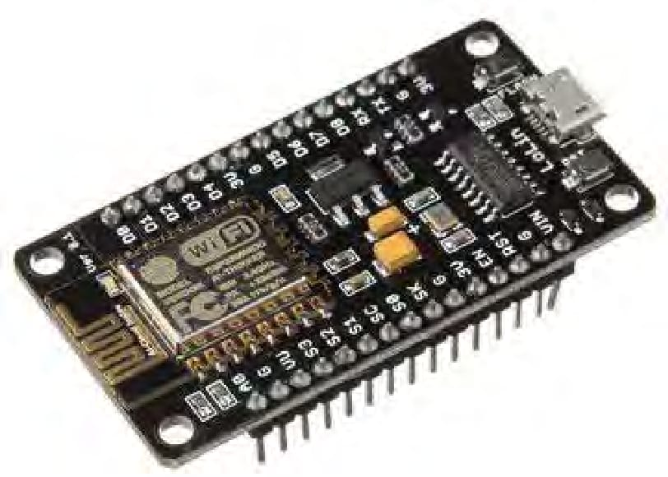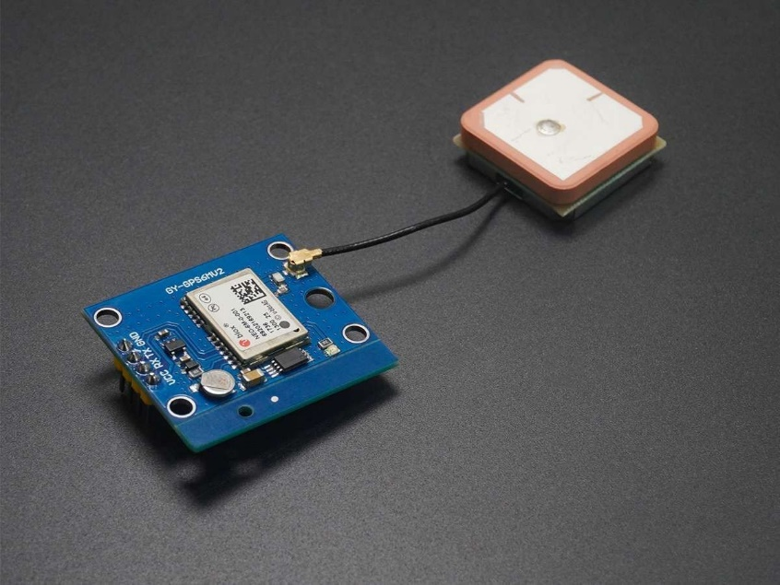

# (GPS Module) (ESP8266)

# 2)Analysis :

# Analyzing the problem space involved understanding the limitations of existing solutions and identifying user pain points.

# Challenges:

# Signal interference indoors or in obstructed areas.

# Maintaining stable Wi-Fi connectivity.

# Formatting GPS data for user-friendly display.

# Visualization:

# Created user personas: A logistics manager monitoring fleet vehicles, a solo traveler ensuring safety, and a homeowner tracking assets.

# Developed journey maps for scenarios like live tracking, ensuring seamless interaction between the GPS module, ESP8266, and the Google Maps interface.

# 

# 3)Ideate :

# Brainstorming and creativity techniques led to innovative solutions:

# Explored various output formats, such as dynamic URLs and app-based notifications.

# Proposed alternative implementations like SMS-based location sharing for areas with limited internet access.

# Used mind maps to design features like geofencing and power-saving modes.

# 

# Algorithm of the program :

# S1) START

# S2) CONNECT TO WIFI NETWORK

# S3) CONNECTED TO WIFI NETWORK

# S4) GET LATITUDE AND LONGITUDE FROM GPS MODULE

# S5) INPUT THE DATA TO MICROCONTROLLER

# S6) GENERATE A URL LINK FOR GOOGLE MAPS USING THE LATITUDE AND LONGITUDE

# S7) PASTE THE LINK ON THE BROWSER

# S8) END

# Pseudocode of the program :

# START

# Step 2: Connect to Wi-Fi network

# CONNECT_TO_WIFI()

# Step 3: Check if connected to Wi-Fi network

# IF WIFI_CONNECTED THEN

# PRINT "CONNECTED TO WIFI NETWORK"

# Step 4: Get latitude and longitude from GPS module

# latitude, longitude = GET_GPS_COORDINATES()

# Step 5: Input the data (latitude and longitude) to the microcontroller

# SEND_TO_MICROCONTROLLER(latitude, longitude)

# Step 6: Generate a URL link for Google Maps using latitude and longitude

# google_maps_link = "https://www.google.com/maps?q=" + latitude + "," + longitude

# Step 7: Paste the link on the browser

# OPEN_BROWSER(google_maps_link)

# END

# Flowchart of the program :

# 

# 4) Build :

# This phase focused on developing the system and creating prototypes:

# Soft Prototyping:

# Designed a flowchart to visualize the data flow from the GPS module to the user interface.

# Hard Prototyping:

# Created a circuit diagram showing the NEO 6M GPS module connected to ESP8266 via the SoftwareSerial interface.

# System architecture included Wi-Fi connectivity for data transmission and URL generation.

# 

**(Wiring Diagram)**

# 5)Test:

# Extensive testing ensured functionality and reliability:

# Test Cases:

# Verify GPS data transmission when the signal is weak (< 20 dBm).

# Test URL generation for incorrect latitude/longitude inputs.

# Check latency in live updates over varying Wi-Fi speeds.

# Feedback: Users reported occasional delays in URL generation in low-signal areas. This was resolved by optimizing data processing code.

# 

**6)Implement:**

**The implementation highlights cost-efficiency and scalability:**

* **Business Model:**
  1. **SaaS platform targeting fleet management and personal safety, offering subscription tiers for real-time tracking frequency.**
  2. **Features include historical tracking data, live monitoring, and geofencing alerts.**
* **Future Enhancements:**
  1. **Add mobile app support for a better user experience.**
  2. **Implement machine learning to predict movement patterns and enhance geofencing.**

